

American International University-Bangladesh (AIUB)  
Department of Computer Science  
Faculty of Science &Technology (FST)  
FALL 24-25

Section: B

Project Management Plan

For

All-in-One Medicare Application

Report submitted

By

|  |  |  |
| --- | --- | --- |
| SN | Student Name | Student ID |
| 1 | Farjana Zaman Mithela | 21-44480-1 |
| 2 | Hossain Al Arik | 21-44776-1 |
| 3 | Sobhan Ibne Hasan | 21-44682-1 |
| 4 | Md. Radowan Ahammed | 19-40922-2 |

Table of Contents

Revision History Error! Bookmark not defined.

1. TEST PLAN IDENTIFIER: RS-MTP01.3 Error! Bookmark not defined.

2. REFERENCES Error! Bookmark not defined.

3. INTRODUCTION Error! Bookmark not defined.

Background to the Problem **Error! Bookmark not defined.**

Solution to the Problem **Error! Bookmark not defined.**

4. REQUEIREMNT SPECIFICATION Error! Bookmark not defined.

4.1 System Features **Error! Bookmark not defined.**

4.2 System Quality Attributes **Error! Bookmark not defined.**

4.3 System Interface **Error! Bookmark not defined.**

4.4 Project Requirements **Error! Bookmark not defined.**

5. FEATURES NOT TO BE TESTED Error! Bookmark not defined.

6. TESTING APPROACH Error! Bookmark not defined.

6.1 Testing Levels **Error! Bookmark not defined.**

6.2 Test Tools **Error! Bookmark not defined.**

6.3 Meetings **Error! Bookmark not defined.**

7. TEST CASES/TEST ITEMS Error! Bookmark not defined.

8. ITEM PASS/FAIL CRITERIA Error! Bookmark not defined.

9. TEST DELIVERABLES Error! Bookmark not defined.

10. STAFFING AND TRAINING NEEDS Error! Bookmark not defined.

11. RESPONSIBILITIES Error! Bookmark not defined.

12. TESTING SCHEDULE Error! Bookmark not defined.

13. PLANNING RISKS AND CONTINGENCIES Error! Bookmark not defined.

14. APROVALS Error! Bookmark not defined.

**Software Project Management Plan**

**Project Title:** All-in-One Medicare App: A unified, secure, and efficient solution to any medical needs.

**1. Introduction**

This Project Management Plan outlines the framework and strategy for the successful execution of the "All-in-One Medicare App" project. This document serves as a comprehensive guide, detailing the project's objectives, scope, and methodologies while addressing the needs and expectations of key stakeholders, including patients (customers), healthcare providers, investors and development teams.

This platform (All-in-One Medicare App) aims to integrate healthcare services such as appointment scheduling, pharmacy orders, diagnostics, and secure payment solutions into a single, user-friendly application.

While this introductory section provides a summarized framework of the project's purpose and scope, the subsequent sections of the Project Management Plan will delve into greater detail regarding specific aspects such as project objectives, scope management, schedule, budget, and risk management.

**2.** **Project Title:**

**All-in-One Medicare App:** A unified, secure, and efficient solution to any medical needs.

**3.** **Objectives**

**Main Objective:**

To develop a centralized and user-friendly digital healthcare platform that integrates multiple services into one app to enhance accessibility, convenience, and healthcare management.

Key Highlights:

1. Unified Healthcare Services: Combines appointment scheduling, pharmacy orders, payments, and diagnostics in a single platform.
2. Enhanced User Convenience: Provides location-based services, emergency support, and AI-powered health tools.
3. Improved Health Management: Offers centralized storage for medical records, reminders, and health tips.
4. Secure and Scalable: Ensures data security, reliable payments, and future-ready architecture for additional features.

**Sub-Objectives:**

1. User Accessibility

* Enable seamless user registration, login, and profile management.
* Provide easy access to personalized medical records and history.

1. Healthcare Service Integration

* Facilitate appointment scheduling, rescheduling, and reminders.
* Allow users to find nearby hospitals, clinics, and pharmacies using geolocation.

1. Pharmacy and Medicine Delivery

* Provide a platform for ordering medicines from verified pharmacies.
* Offer delivery options with integrated payment systems (card and cash-on-delivery).

1. Emergency Support

* Ensure quick access to emergency contacts and services.
* Provide a responsive interface for emergency situations.

1. AI-Powered Diagnostics

* Integrate AI-based scanning and health diagnostics for user convenience.
* Offer automated health suggestions based on diagnostic reports.

1. Secure Payment Solutions

* Support multiple payment options, including card payments and cash-on-delivery.
* Ensure secure transactions with data encryption and privacy protection.

1. Administrative Efficiency

* Empower Admins to manage users, services, and system data effectively.
* Provide tools for adding, updating, removing, or banning users/entities.

1. Promote Health Awareness

* Offer health tips, reminders, and notifications to encourage healthy lifestyles.
* Enable users to stay informed about their medical routines.

**4. Justification**  
The project addresses the complex healthcare landscape by providing a centralized platform for healthcare management, benefiting patients, healthcare providers, and administrators through enhanced accessibility, convenience, and operational efficiency. From a business and profit perspective, the platform opens avenues for revenue generation through subscription-based services, premium features, and partnerships with healthcare providers and pharmacies. By streamlining healthcare operations and offering a scalable, user-centric solution, the project has the potential to attract a large user base, strengthen market competitiveness, and create a sustainable model for long-term financial growth.

**5. System Overview**

The application will feature modules for user management, healthcare service integration, emergency support, pharmacy orders, AI diagnostics, and payment processing, ensuring a comprehensive healthcare solution.

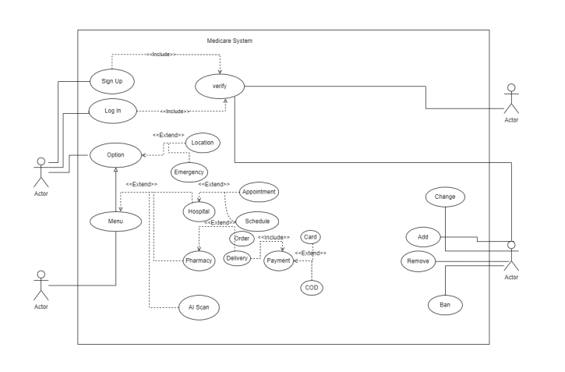

Actors: Represented by the stick figures

* 1. General Users:

• Patients, Hospitals, Independent doctors and Pharmacies.

* 1. Admin

• Represents users with administrative privileges for managing the app.

Left top: Main user/patient/customer, Left bottom: Hospitals/doctors/pharmacies

Right top: 3rd party payment/user verification system, Right bottom: Admin

**6. Stakeholder Analysis**

**Primary Stakeholders:**

1. **Project Development Team** – Responsible for designing, building, testing, and deploying the platform.
2. **Project Sponsors** – Provide financial resources and strategic direction for the project.
3. **Patients (Main Users)** – The end-users of the platform, benefiting from its healthcare services.
4. **Doctors/Healthcare Providers** – Use the platform to manage appointments and interact with patients.
5. **Pharmacies** – Facilitate medicine orders and deliveries through the platform.
6. **System Administrators (Admins)** – Oversee platform maintenance, user management, and system data.
7. **Hospitals and Clinics** – Provide location-based services and integrate with the app's functionality.
8. **Emergency Services** – Ensure quick access to emergency contacts and services via the platform.

**Secondary Stakeholders:**

1. **Management** – Oversee the overall project operations and ensure alignment with organizational goals.
2. **Investors** – Provide funding with an interest in the project’s financial return and success.
3. **External Partners** – Include third-party service providers, vendors, or collaborators supporting the platform.

**7**. **Feasibility study**

**1. Technical Feasibility**

* **Platform Compatibility:**  
  The app can be developed for both Android and iOS platforms using modern development tools such as **Android Studio**, **Xcode**, and cross-platform frameworks like **Flutter** or **React Native** for efficient development. A web version could also be created for broader accessibility.
* **Technology Stack:**  
  The application will require:
  + **Frontend:** Flutter/React Native for mobile app development.
  + **Backend:** Node.js or Django for server-side logic, integrated with a secure and scalable database like MySQL or Firebase.
  + **AI Integration:** AI-based diagnostic tools can leverage libraries such as TensorFlow or PyTorch.
  + **Geolocation Services:** APIs such as Google Maps or OpenStreetMap for location-based services.
  + **Payment Gateway Integration:** Services like Stripe or PayPal for secure transactions.
* **Data Security:**  
  Strong encryption protocols (e.g., AES-256) and compliance with healthcare data standards like **HIPAA** and **GDPR** are necessary to ensure user data protection.
* **Scalability and Maintenance:**  
  Cloud platforms like **AWS** or **Google Cloud** will be used to ensure the app can handle a growing user base and support future feature additions.

Technically, the project is feasible as all required technologies and tools are widely available. Skilled developers, designers, and AI engineers will be needed to handle the technical complexities.

**2. Financial Feasibility**

* **Estimated Development Costs:**
  + **Frontend and Backend Development:** $50,000
  + **AI Diagnostics Integration:** $20,000
  + **Testing and Quality Assurance:** $10,000
  + **Cloud Infrastructure and Hosting:** $5,000
  + **Miscellaneous Costs (licenses, tools):** $5,000
  + **Total Development Cost:** $90,000
* **Revenue Streams:**
  + - **Subscription Plans:** Monthly or yearly subscriptions for premium features like advanced diagnostics, reminders, and exclusive health tips.
    - **Transaction Fees:** A percentage fee from pharmacies and healthcare providers for transactions made through the platform.
    - **Partnerships:** Collaborations with clinics, hospitals, and pharmacies for advertising and sponsored listings.
    - **Advertisements:** Ads from health-focused brands, displayed in non-intrusive areas.
* **Potential ROI (Return on Investment):**  
  With an estimated user base of 10,000 users in the first year and a modest subscription fee of 500 Taka/month, the platform could generate 60,000,000 crore Taka annually (excluding other revenue streams). This exceeds the development and operational costs, making it financially viable.
* **Risks and Mitigation:**
  + **Risk:** Initial high investment.  
    **Mitigation:** Secure funding from investors or sponsors to distribute costs.
  + **Risk:** Slow user adoption.  
    **Mitigation:** Invest in marketing and user education campaigns to increase awareness and adoption.

The "All-in-One Medicare Application" is both technically and financially feasible. With the availability of modern tools and a well-defined revenue model, the project has significant potential for success, provided it is executed with careful planning and efficient resource allocation.

**8. Process Model to be Followed**

The **Agile Scrum** methodology will be used for its iterative nature, emphasis on collaboration, and ability to prioritize features based on feedback.

**9. Work Breakdown Structure (WBS)**

1. Project Management and Planning
2. Technical Feasibility
3. Financial Feasibility
4. Software Development
5. Deployment and Support

**10. Effort Estimation**

Based on the complexity, the project will require 5 developers—2 for the frontend, 2 for backend, and 1 for database management. We will allocate tasks over a 4-month period.

Effort estimation will be based on **Expert Judgment** and **Bottom-Up Estimation**, ensuring accuracy and thorough planning.

**11. Resource Requirements**

**Software Requirements:** Android Studio, Xcode, Visual Studio Code, Firebase, AWS.

**Hardware Requirements:** Development workstations, testing devices, high-performance servers. **Human Resource Requirements:** Project Manager, Developers, QA Engineers, UI/UX Designers, Security Experts.

For Project: Development team, servers, cloud storage, and API access.

For Clients: Smartphones or computers with internet access.

**12. Project Schedule**

The project will follow a six-sprint structure, with each sprint lasting two weeks, focusing on different development phases, from infrastructure setup to final deployment.

**13. Delivery Plan**

Each sprint will deliver incremental improvements, starting with foundational features and progressing to comprehensive testing and deployment.

**14. Risk Analysis**

Risks include technical challenges, user adoption, and financial constraints, which will be mitigated through proactive management and iterative development.

Data Breach: Strong encryption measures will be implemented to protect sensitive medical data.

Technical Failures: Redundant servers will be used to prevent service outages.

**15. Quality Control Plan**

Regular code reviews, comprehensive testing, and user feedback will ensure quality and continuous improvement.

**16. Budget**

The total budget is estimated at **170,000 ₺**, covering development, testing, project management, and post-launch support.

Development Cost: $30,000

Maintenance: $5,000/year

Marketing: $10,000

**17. Conclusion**

The "All-in-One Medicare Application" aims to revolutionize healthcare accessibility and management, providing a secure and scalable solution that meets the needs of patients and healthcare providers.

* **PROJECT SCHEDULE:**

| **Sprint No.** | **Week 1** | **Week 2** | **Week 3** | **Week 4** | **Week 5** | **Week 6** | **Week 7** | **Week 8** | **Week 9** | **Week 10** | **Week 11** | **Week 12** |
| --- | --- | --- | --- | --- | --- | --- | --- | --- | --- | --- | --- | --- |
| 1 | ██ | ██ |  |  |  |  |  |  |  |  |  |  |
| 2 |  |  | ██ | ██ |  |  |  |  |  |  |  |  |
| 3 |  |  |  |  | ██ | ██ |  |  |  |  |  |  |
| 4 |  |  |  |  |  |  | ██ | ██ |  |  |  |  |
| 5 |  |  |  |  |  |  |  |  | ██ | ██ |  |  |
| 6 |  |  |  |  |  |  |  |  |  |  | ██ | ██ |

* **Activity-Based WBS (SDPM Ch 07)**

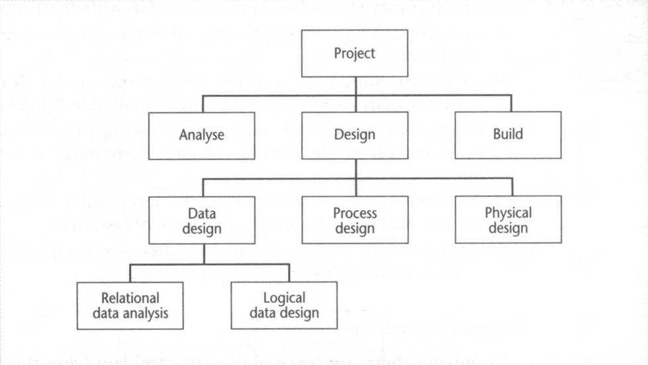

* **Product-Based WBS**

* **Risk Projection**

We'll assess the likelihood and impact of potential risks, estimating their consequences.

* **Risk 1: Inadequate User Adoption**
  + **Likelihood:** High (70%)
  + **Impact:** High (loss of user base and potential revenue)
  + **Consequences:** Reduced profitability and failed project objectives.
* **Risk 2: Data Security Breach**
  + **Likelihood:** Medium (50%)
  + **Impact:** Catastrophic (legal penalties, loss of user trust)
  + **Consequences:** Severe financial and reputational damage.
* **Risk 3: Delays in Development**
  + **Likelihood:** Medium (60%)
  + **Impact:** Moderate (extended timelines, increased costs)
  + **Consequences:** Budget overruns and delayed deployment.
* **Risk 4: Integration Failures**
  + **Likelihood:** Medium (50%)
  + **Impact:** High (service interruptions)
  + **Consequences:** Reduced functionality and user dissatisfaction.
* **Risk Decision Tree**

**Scenario: Choosing Between Two Development Approaches**

* **Option A: Traditional Development Approach**
  + **Probability of Success:** 80%
  + **Impact if Fails:** Moderate
  + **Consequence if Fails:** $50,000 loss
  + **Expected Cost:** $50,000 * 20% = $10,000
* **Option B: Agile Development Approach**
  + **Probability of Success:** 60%
  + **Impact if Fails:** High
  + **Consequence if Fails:** $100,000 loss
  + **Expected Cost:** $100,000 * 40% = $40,000

**Calculation:**

* **Total Risk Exposure for Option A:** $10,000
* **Total Risk Exposure for Option B:** $40,000

Based on these calculations, **Option A** presents a lower risk exposure.

* **Risk Table**

| **Risk** | **Likelihood** | **Impact** | **Risk Exposure (RE)** |
| --- | --- | --- | --- |
| Inadequate User Adoption | High (0.7) | High | RE = 0.7 * High Impact |
| Data Security Breach | Medium (0.5) | Catastrophic | RE = 0.5 * Catastrophic Impact |
| Delays in Development | Medium (0.6) | Moderate | RE = 0.6 * Moderate Impact |
| Integration Failures | Medium (0.5) | High | RE = 0.5 * High Impact |

* **BUDGET:**

Budget using COCOMO Model:

**1.** **Estimate Effort:**

• Lines of Code (LOC): Based on the features and scope described, All-in-one Medicare App is estimated to require approximately 15,000 LOC.

• Effort Multiplier (EM): Considering the risk factors and project complexity, an EM of 1.3 is reasonable.

• Person-Months (PM) = (15,000 LOC * 1.3 EM) / 100 = 195 PM

**2.** **Calculate Development Cost:**

• Programmer Cost per Month: Assume Taka 40,000 per month per programmer.

• Total Development Cost = 195 PM * Taka 40,000/PM = Taka 7,800,000

**3. Additional Costs:**

• Hardware and Software: Taka 200,000

• Project Management: Taka 300,000

• Testing and Quality Assurance: Taka 200,000

• Maintenance and Support: Taka 100,000

**4. Total Project Budget**:

• Taka 7,800,000 (Development) + Taka 200,000 (Hardware/Software) + Taka 300,000

(Project Management) + Taka 200,000 (Testing/QA) + Taka 100,000

(Maintenance/Support) = Taka 8,600,000

**\*\*5. Profit and Final Price:**

• Profit Margin: Assume 25%

• Profit = Taka 8,600,000 * 25% = Taka 2,150,000

• Final Price = Taka 8,600,000 + Taka 2,150,000 = Taka 10,750,000

**Please note:** This budget is an estimate based on the information provided and can vary depending on several factors.

**Recommendations:**

• **Mitigate risks**: Address identified risks through proactive measures like training developers, using well-defined requirements, and implementing continuous integration and continuous delivery (CI/CD) practices.

• **Track progress:** Monitor project progress against the baseline estimates and adapt the budget if necessary.

**• Plan for contingencies:** Build a buffer into the budget to handle unforeseen challenges.

**2. Project Management Approach**

The project will follow an **Agile** approach with **Scrum** methodology to ensure flexibility, continuous improvement, and iterative delivery. Key roles include:

1. Project Manager: Responsible for overall project coordination, planning, and execution. The Project Manager oversees the project timeline, budget, and resources, ensuring alignment with project goals and stakeholder expectations.

2. Development Team: Comprising software developers, AI engineers, UX/UI designers, and quality assurance (QA) engineers, the development team is responsible for building, testing, and deploying the Medicare App. Each team member brings specialized expertise to the project, contributing to its success.

3. Stakeholders: Stakeholders, including users, managers, decision-makers, and external partners, play a vital role in providing feedback, support, and resources throughout the project lifecycle. Their involvement ensures that project deliverables meet the needs and expectations of end users and stakeholders.

Resource constraints and limitations are identified and addressed proactively to mitigate risks and ensure project success. Any decisions requiring authorization, such as additional funding or changes to project scope, will be communicated and approved by the project sponsor or designated authority.

The project management approach emphasizes transparency, accountability, and flexibility, allowing for adaptability to changing requirements and unforeseen challenges. Regular project status updates, meetings, and reporting mechanisms facilitate effective communication and decision-making, ensuring alignment with project objectives and stakeholder expectations.

By adhering to this project management approach, we aim to deliver a successful IdeaGenius platform that meets user needs, drives innovation, and achieves project goals within the specified timeline and budget.

**4. Project Scope**

The application will include user management, appointment scheduling, pharmacy integration, AI diagnostics, and secure payment processing.

The project scope includes:

1. Designing and developing the IdeaGenius platform, including frontend and backend components, AI algorithms, and user interfaces.

2. Implementing features such as personalized idea generation, real-time collaboration, task management, and internet support.

3. Testing the platform for functionality, usability, and performance to ensure a seamless user experience.

4. Deploying the platform in a production environment, including server setup, configuration, and optimization.

5. Providing training and support to users to facilitate adoption and maximize platform utilization.

The project does not include:

1. Customization beyond the defined scope of features and functionalities.

2. Integration with third-party systems or services unless explicitly specified.

3. Hardware procurement or infrastructure setup beyond the requirements for platform deployment.

4. Ongoing maintenance and support beyond the initial deployment phase, unless agreed upon separately.

1. **Milestone List**

The IdeaGenius project encompasses several key milestones essential for the successful development, deployment, and adoption of the platform. Each milestone represents a significant stage in the project lifecycle, marking key achievements and progress towards project objectives. The milestones outlined below provide insight into the major phases of the project, including requirements gathering, design, development, testing, documentation, and deployment. As we progress through these milestones, our focus remains on delivering a robust, user-friendly platform that empowers individuals and teams to unleash their creative potential and drive innovation. Effective communication, collaboration, and stakeholder engagement will be paramount as we navigate through each milestone, ensuring alignment with project goals and expectations.

* **SRS Completion:** 25/01/2025
* **Design Completion:** 05/02/2025
* **Coding Completion:** 25/03/2025
* **Testing and Debugging:** 15/04/2025
* **User Guides and Installation:** 25/04/2025

**Contact us:**

You can contact us with any of the following ways:

Phone: 017XXXXXXXX

E-mail: [G10softwaresolutions@gmail.com](mailto:G10softwaresolutions@gmail.com)

Fax: +1-212-555-1234

Website: <http://www.G10softwaresolutions.com/>

We look forward to hearing from you.

Regards,

G10 Software Solutions